WEEK 3 FOOTPRINTING AND RECONNAISANCE

Fig: 1 Workspace Creation, Listing and available modules
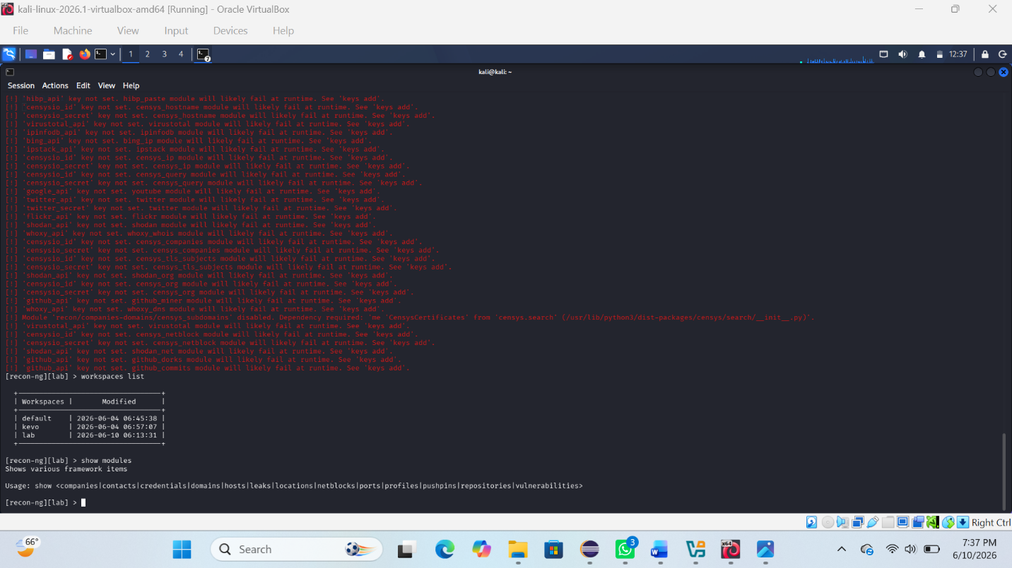

Fig: 2 Whois lookup
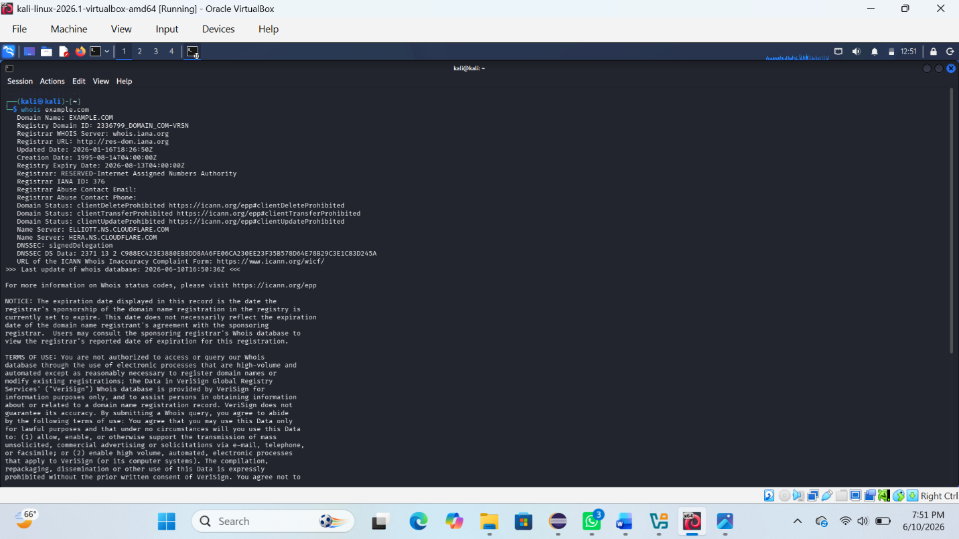
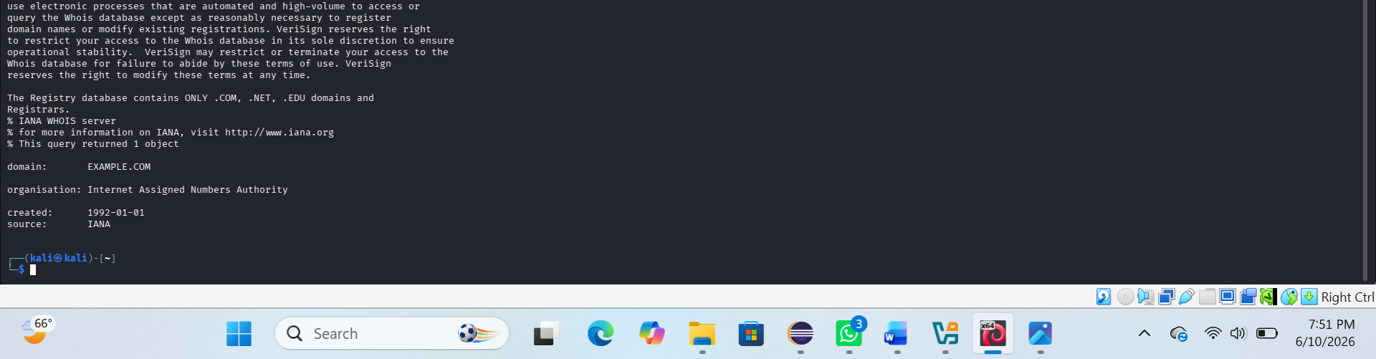

REFLECTION:
I learned footprinting techniques using Recon-ng and OSINT tools to gather basic information about a target system and domain.

